LETSDEFEND LAB WRITEUP 01 / 06

How to Investigate a SIEM Alert
  - Course-level learning summary, backed by supplied screenshot

Learning focus
A SOC triages an alert by validating context, checking correlated logs and deciding whether the signal represents an incident.

Key concepts covered
- Review the alert, time, source, destination and detection rule.
- Pivot to endpoint/network evidence and scope affected assets.
- Record disposition, rationale and escalation decision.

How a SOC analyst would use these skills
- Preserve incident context (time, affected user/host, evidence, and severity).
- Correlate endpoint and network alerts with relevant log source records.
- Explain next steps and avoid marking an event malicious without validation.

Provided evidence and limitation
Learner reports completing this free course. The screenshot supplied in Week 3 ZIP shows the training page; it does not by itself prove every sub-question or hands-on action. No individual quiz answers are invented here.
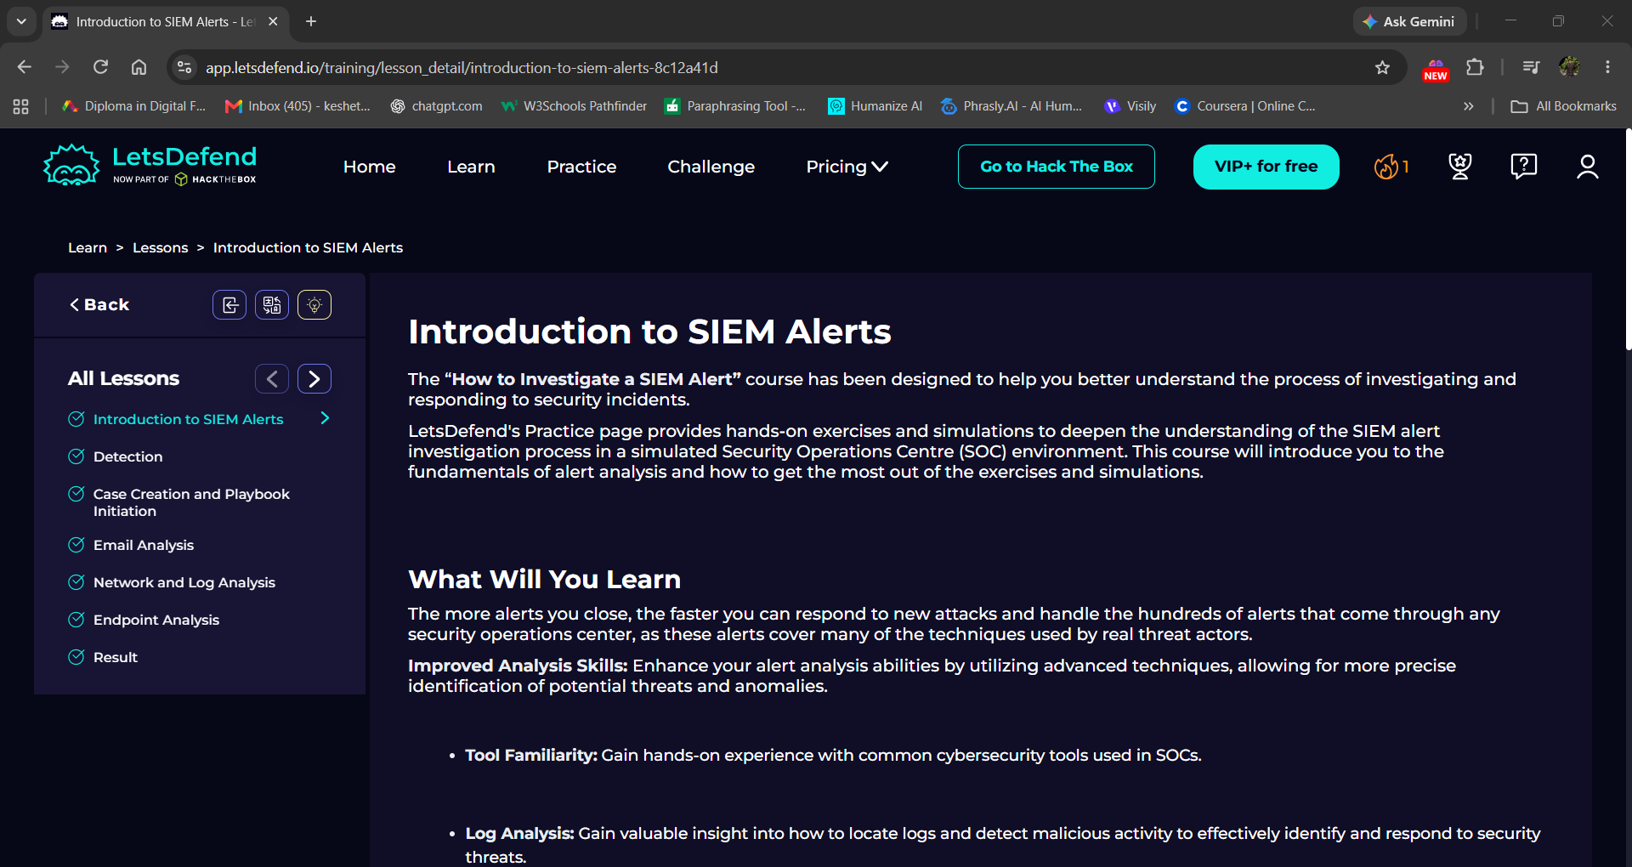
Evidence: LetsDefend training screenshot – How to Investigate a SIEM Alert

Reflection
I connected this course to the practical Week 3 tasks: Sysmon for Windows endpoint events, auditd for Linux commands and Snort for network detection. This is a course-level reflection, not an unverified transcript of every lesson.

